**DAILY ONLINE ACTIVITIES SUMMARY**

|  |  |  |  |  |  |  |  |  |
| --- | --- | --- | --- | --- | --- | --- | --- | --- |
| **Date:** | 23-06-2020 | | | | | **Name:** | K S Prajwal | |
| **Sem & Sec** | IV A sec | | | | | **USN:** | 4AL18CS032 | |
| **Online Test Summary** | | | | | | | | |
| **Subject** | | Iot | | | | | | |
| **Max. Marks** | | 15 | | **Score** | | | 11 | |
| **Certification Course Summary** | | | | | | | | |
| **Course** | Iot | | | | | | | |
| **Certificate Provider** | | | --- | | **Duration** | | | **2 hr** |
| **Coding Challenges** | | | | | | | | |
| **Problem Statement:**  1: program to find modular exponentiation | | | | | | | | |
| **Status:** completed | | | | | | | | |
| **Uploaded the report in Github** | | | | | yes | | | |
| **If yes Repository name** | | | | | <https://github.com/alvas-education-foundation/KS_Prajwal> | | | |
| **Uploaded the report in slack** | | | | | yes | | | |

Online Test Details: (Attach the snapshot and briefly write the report for the same)

Certification Course Details: (Attach the snapshot and briefly write the report for the same)

Coding Challenges Details: (Attach the snapshot and briefly write the report for the same)

**Online Test Details:**

The test for today was from Iot. The test was of objective type questions and there were 15 questions and the duration was 20 minutes. The questions were optimal and easy. The score that I got was 11/15

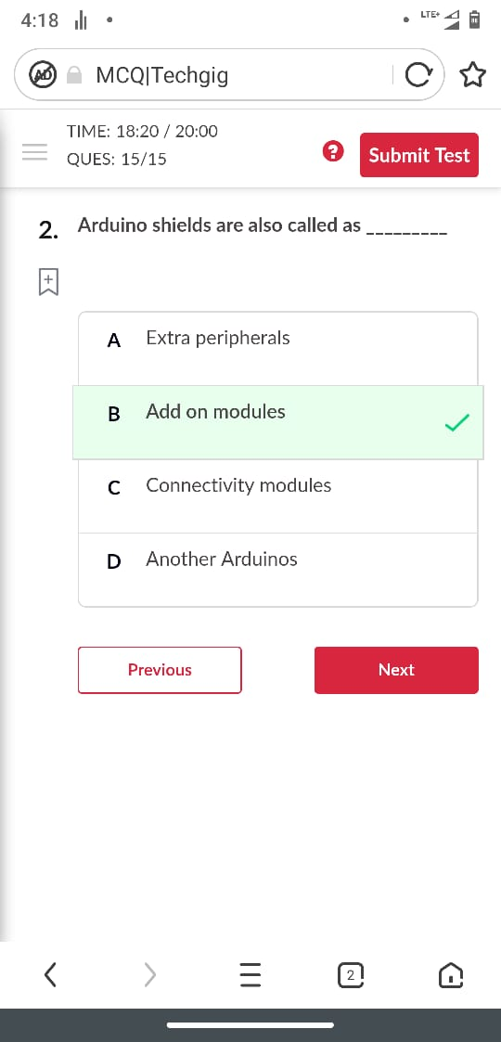

Snapshot of certification course:

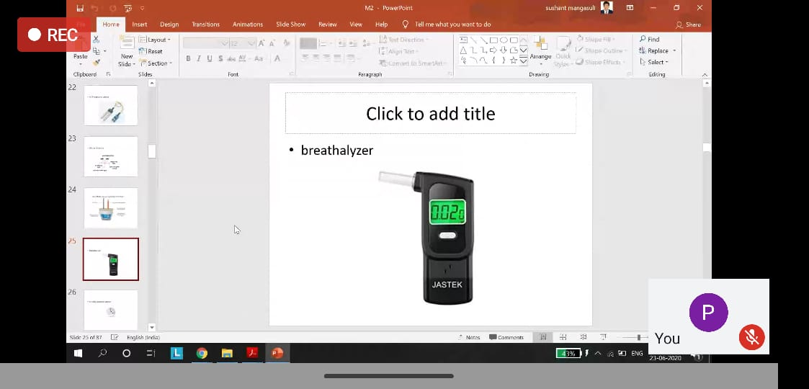

Today was about the types of the sensors user in the Iot and there application, and also the components of the Arduino board and familiarization of Arduino and the programing in board using the IDE.

**Online coding:**

Problem 1: (using JAVA) program to find modular exponentiation

